Objectives:

* Chapter 10 Inheritance

**There are 3 projects, each worth 33.3%**

**Project #1**

(Employee and Production Worker Classes). Complete the following assignment below.

**#1 print screen the output and code below here.**

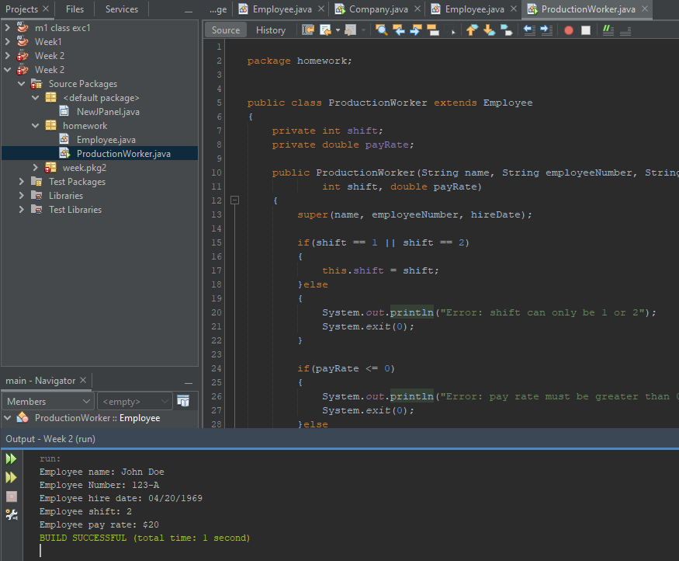

**Project #2**

(Essay Class). Complete the following assignment below.

**#2 print screen the output and code below here.**

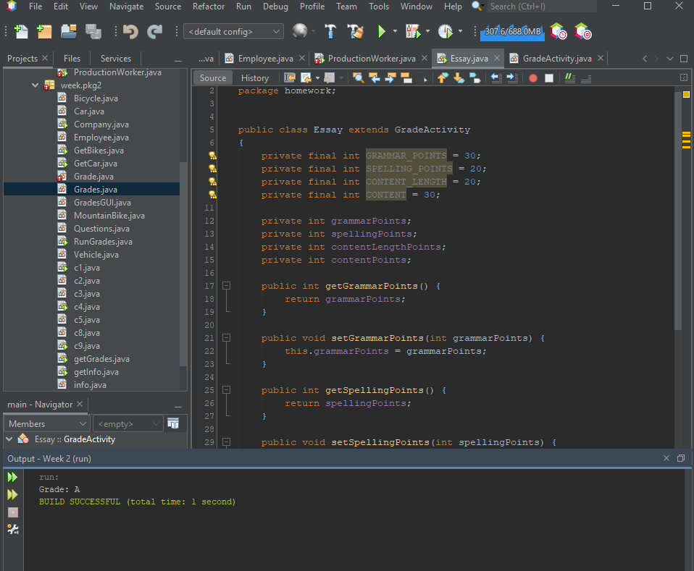

**Project #3**

(Person and Customer Classes). Complete the following assignment below.

**#3 print screen the output and code below here.**

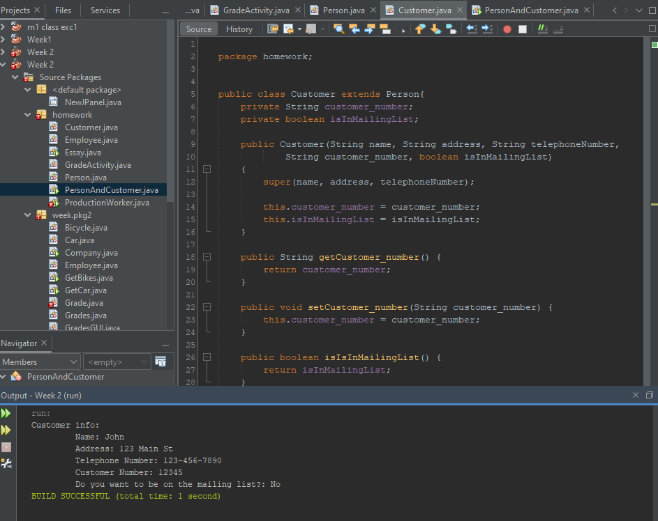

**Submit this document to Module 2 Homework.**